Consider the following three tables from which you in the database which comes from different operational systems.

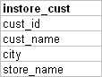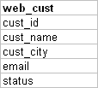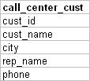

Consider the following rules while processing the data from these three tables and populate the dimension table, if you see any error records, insert the same to rejection table

* Web cust
  + Email is a must, Email must have @,Status <> ‘Bounced’
* Call center
  + Phone number is a must, If no sales rep name reject those records
* instore_cust
  + Store name is a must, if there is no store then reject
  + Customer Name, city is a must, if you don’t have any values in this two columns, reject the same.
* Priority of selection (1.Instore, 2.Call center 3.Web)
* The Unique key to identify the duplicate is cust_name and city. (cust_name and city)
* **TARGET TABLE (CUST_DIM)**

CUST_ID   
CUST_NAME   
CITY   
EMAIL  
PHONE  
REP_NAME  
SRC_CUST_ID   
SOURCE (Valid values are WEB, CALLCENTER,INSTORE)

* **REJECT TABLE (CUST_REJ)**

REJ_ID  
SRC_REC  
REASON